State Diagram:

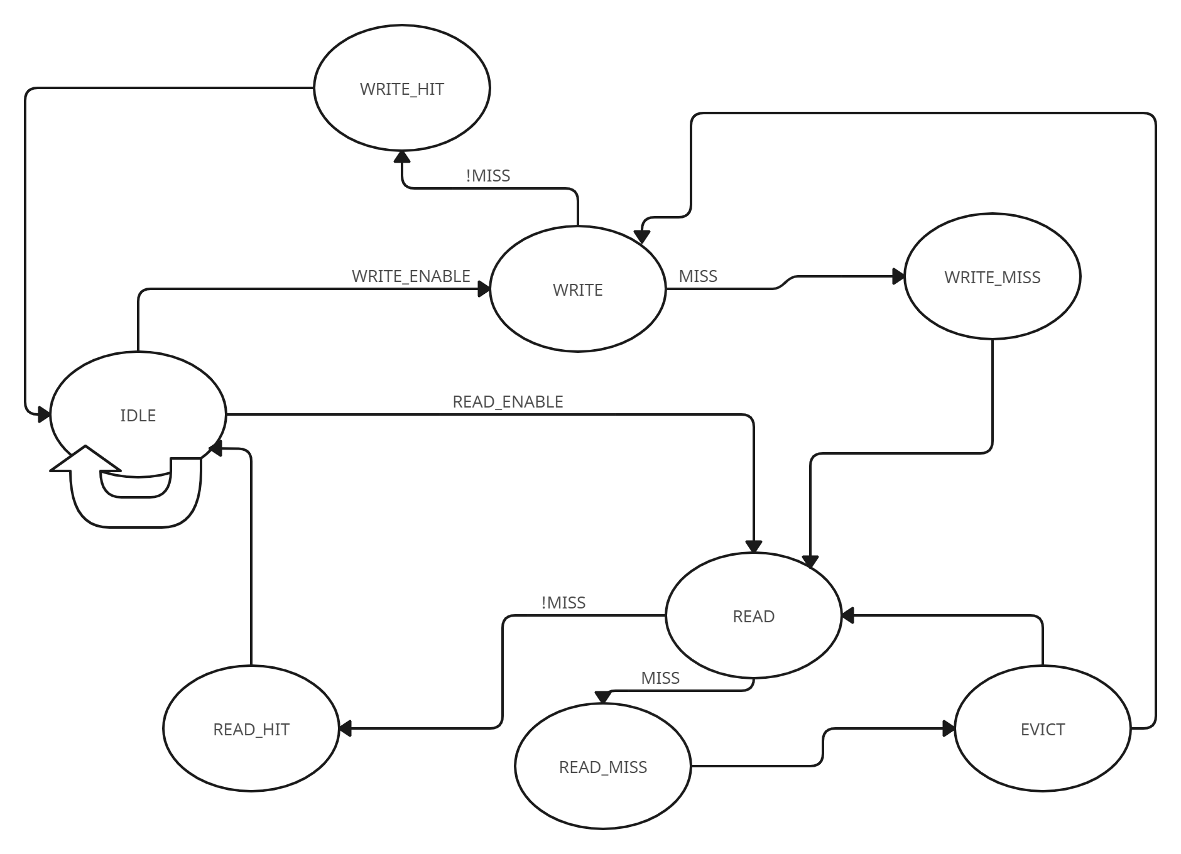

Block Diagram:

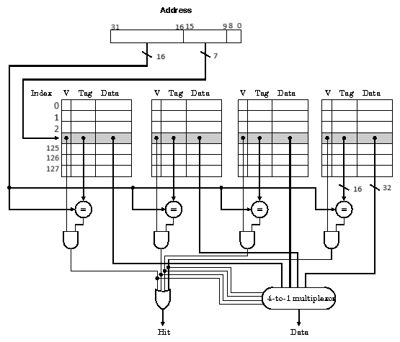

Description and Justification of the Chosen HDL

Description

The provided code implements a cache controller using Verilog, a hardware description language (HDL) widely used for digital system design. The cache controller manages read and write operations between a processor and memory, improving access speed and efficiency. Here’s a breakdown of the main components and functionalities of the cache controller:

1. Clock and Reset Handling:

- `clk` (Clock): Drives the sequential logic of the cache controller.

- `rst` (Reset): Initializes the cache controller to a known state.

2. Inputs and Outputs:

- Inputs:

- `address` (32-bit): Memory address for read/write operations.

- `WriteData` (32-bit): Data to be written to the cache.

- `read_enable` (1-bit): Control signal to initiate a read operation.

- `write_enable` (1-bit): Control signal to initiate a write operation.

- Outputs:

- `ReadData` (32-bit): Data read from the cache.

- `EvictData` (32-bit): Data evicted from the cache during a miss.

- `current_state` (4-bit): Current state of the cache controller’s state machine.

3. Cache Organization:

- Parameters define the cache size, block size, number of sets, and associativity.

- Arrays for storing cache data (`cache`), valid bits (`valid`), dirty bits (`dirty`), tags (`tag`), and age bits (`age`) for implementing the Least Recently Used (LRU) eviction policy.

4. State Machine:

- A finite state machine (FSM) controls the cache controller, transitioning between states such as `idle`, `read`, `write`, `read_hit`, `read_miss`, `write_hit`, `write_miss`, and `evict`.

5. Control Logic:

- Determines the next state based on the current state, address, and control signals.

- Manages data flow, including reading from and writing to the cache, handling hits and misses, and evicting data when necessary.

6. Cache Operations:

- Read Hit: Data is directly read from the cache.

- Read Miss: The cache line is evicted if necessary, and new data is loaded into the cache.

- Write Hit: Data is written to the cache and marked as dirty.

- Write Miss: If an empty line is available, data is written and marked valid; otherwise, eviction occurs.

7. Testbench:

- A testbench (`tb_cache_controller`) is provided to simulate and verify the functionality of the cache controller, including initializing signals, generating clock pulses, and performing read/write operations.

Justification for Choosing Verilog

1. Industry Standard:

- Verilog is a widely adopted HDL in the semiconductor and digital design industry. It is supported by numerous simulation and synthesis tools, making it a preferred choice for designing, verifying, and implementing digital systems.

2. Simplicity and Efficiency:

- Verilog’s syntax and structure are straightforward, allowing designers to describe complex hardware behaviors efficiently. The language’s constructs facilitate modeling of both combinational and sequential logic, making it suitable for designing components like cache controllers.

3. Support for Hierarchical Design:

- Verilog supports hierarchical design, enabling the modular development of large systems. The cache controller can be designed as a module and easily integrated into larger designs, such as CPUs or memory subsystems.

4. Simulation and Verification:

- Verilog provides robust support for simulation and verification. Testbenches can be written to simulate the behavior of the cache controller, ensuring correctness before hardware implementation. This reduces the risk of errors and design flaws.

5. Synthesizable Constructs:

- Verilog includes constructs that can be synthesized into actual hardware. The cache controller described in Verilog can be synthesized into an FPGA or ASIC, making it a practical choice for both prototyping and production.

6. Extensive Tool Support:

- There is extensive tool support for Verilog, including simulation (ModelSim, VCS), synthesis (Synopsys Design Compiler, Xilinx Vivado), and verification (UVM, SystemVerilog). These tools enhance the design and verification process, ensuring high-quality hardware implementations.

7. Community and Resources:

- A large community of Verilog users and a wealth of resources, including tutorials, documentation, and forums, provide valuable support to designers. This makes it easier to learn, troubleshoot, and optimize Verilog designs.

In summary, Verilog was chosen for implementing the cache controller due to its industry acceptance, simplicity, efficiency, support for hierarchical design, robust simulation and verification capabilities, synthesizable constructs, extensive tool support, and a strong community. These factors make Verilog an ideal HDL for designing, testing, and deploying hardware components like the cache controller.

#### Test Bench and Simulation Results

Test Bench covering all states and transitions:

module tb_cache_controller;

// Testbench signals

reg clk;

reg rst;

reg [31:0] address;

reg [31:0] WriteData;

reg read_enable;

reg write_enable;

wire [31:0] ReadData;

wire [31:0] EvictData;

wire [3:0] current_state;

// Instantiate the cache_controller

cache_controller uut (

.clk(clk),

.rst(rst),

.address(address),

.WriteData(WriteData),

.read_enable(read_enable),

.write_enable(write_enable),

.ReadData(ReadData),

.EvictData(EvictData),

.current_state(current_state)

);

// Clock generation

always begin

#5 clk = ~clk;

end

// Counters for hits and misses

integer read_hits = 0;

integer read_misses = 0;

integer write_hits = 0;

integer write_misses = 0;

// Counters for access time

integer read_cycles = 0;

integer write_cycles = 0;

integer total_read_time = 0;

integer total_write_time = 0;

integer total_reads;

integer total_writes;

integer total_accesses;

reg [31:0] read_start_time;

reg [31:32] write_start_time;

always @(posedge clk) begin

if (current_state == uut.read_hit) read_hits = read_hits + 1;

if (current_state == uut.read_miss) read_misses = read_misses + 1;

if (current_state == uut.write_hit) write_hits = write_hits + 1;

if (current_state == uut.write_miss) write_misses = write_misses + 1;

end

// Task to print the cache contents

initial begin

// Initialize signals

clk = 0;

rst = 1;

address = 0;

WriteData = 0;

read_enable = 0;

write_enable = 0;

// Reset the design

#10 rst = 0;

// Test sequence

// 1. Write to cache (miss, then hit)

address = 32'h0000_0000;

WriteData = 32'hFFFF_FFFF;

write_enable = 1;

write_start_time = $time;

#50 write_enable = 0;

write_cycles = $time - write_start_time;

total_write_time = total_write_time + write_cycles;

$display("Write access time: %0d cycles", write_cycles);

uut.print_cache();

// 2. Read from cache (hit)

address = 32'h0000_0000;

read_enable = 1;

read_start_time = $time;

#50 read_enable = 0;

read_cycles = $time - read_start_time;

total_read_time = total_read_time + read_cycles;

$display("Read access time: %0d cycles", read_cycles);

$display("ReadData after read hit: %h", ReadData);

// 3. Write to the same address again (hit)

address = 32'h0000_0000;

WriteData = 32'hAAAA_AAAA;

write_enable = 1;

write_start_time = $time;

#50 write_enable = 0;

write_cycles = $time - write_start_time;

total_write_time = total_write_time + write_cycles;

$display("Write access time: %0d cycles", write_cycles);

uut.print_cache();

// 4. Read from the same address again (hit)

address = 32'h0000_0000;

read_enable = 1;

read_start_time = $time;

#50 read_enable = 0;

read_cycles = $time - read_start_time;

total_read_time = total_read_time + read_cycles;

$display("Read access time: %0d cycles", read_cycles);

$display("ReadData after second read hit: %h", ReadData);

// 5. Write to a new address (miss, then hit)

address = 32'h0001_0000;

WriteData = 32'hBBBB_BBBB;

write_enable = 1;

write_start_time = $time;

#50 write_enable = 0;

write_cycles = $time - write_start_time;

total_write_time = total_write_time + write_cycles;

$display("Write access time: %0d cycles", write_cycles);

uut.print_cache();

// 6. Read from the new address (miss, then hit)

address = 32'h0001_0000;

read_enable = 1;

read_start_time = $time;

#50 read_enable = 0;

read_cycles = $time - read_start_time;

total_read_time = total_read_time + read_cycles;

$display("Read access time: %0d cycles", read_cycles);

$display("ReadData after read miss: %h", ReadData);

// 7. Write to another new address (to test eviction)

address = 32'h0002_0000;

WriteData = 32'hCCCC_CCCC;

write_enable = 1;

write_start_time = $time;

#50 write_enable = 0;

write_cycles = $time - write_start_time;

total_write_time = total_write_time + write_cycles;

$display("Write access time: %0d cycles", write_cycles);

// 8. Evict and write to a previously used address

address = 32'h0003_0000;

WriteData = 32'hDDDD_DDDD;

write_enable = 1;

write_start_time = $time;

#50 write_enable = 0;

write_cycles = $time - write_start_time;

total_write_time = total_write_time + write_cycles;

$display("Write access time: %0d cycles", write_cycles);

// 9. Read after evict

address = 32'h0003_0000;

read_enable = 1;

read_start_time = $time;

#50 read_enable = 0;

read_cycles = $time - read_start_time;

total_read_time = total_read_time + read_cycles;

$display("Read access time: %0d cycles", read_cycles);

$display("ReadData after eviction and read: %h", ReadData);

// Allow time for cache to update

#20;

$display("Final cache state:");

uut.print_cache();

$display("Total Read Access Time: %0d cycles", total_read_time);

$display("Total Write Access Time: %0d cycles", total_write_time);

total_reads = read_hits + read_misses;

total_writes = write_hits + write_misses;

total_accesses = total_reads + total_writes;

$display("Read Hits: %d, Read Misses: %d, Write Hits: %d, Write Misses: %d",

read_hits, read_misses, write_hits, write_misses);

$display("Total Accesses: %d", total_accesses);

// End of test

#200 $finish;

end

endmodule

Performance Metrics:

Execution time:680 ns

Total Read Access Time: 200 cycles

Total Write Access Time: 1242 cycles

Read Hits: 6,

Read Misses: 0,

Write Hits: 5,

Write Misses: 4,

Total Accesses: 15,

Hit Rate 73,3%

#### Design Steps:

1. **Parameter Definition**: Parameters such as cache size, associativity, and block size are defined to configure the cache.
2. **Cache Data Structures**: Arrays are used to represent the cache data, including data, valid bit, dirty bit, tag, and age fields.
3. **State Machine**: The module implements a state machine to manage cache operations, transitioning between states based on read and write requests, cache hits, and cache misses.
4. **Address Decoding**: The address decoder extracts tag, index, and block offset from memory addresses.
5. **State Transition Logic**: The state transition logic determines the next state based on the current state and control signals.
6. **Cache Operation Logic**: Read and write operations are handled based on cache hit or miss conditions.
7. **Eviction Handling**: When the cache is full and a new line needs to be inserted, eviction logic selects the appropriate line for replacement based on the Least Recently Used (LRU) algorithm.
8. **Testbench**: A testbench is created to verify the functionality of the cache controller module using different test scenarios.

### Technical Challenges Encountered and Solutions Implemented:

1. **State Machine Complexity**: Designing a robust state machine to manage cache operations with various control signals and state transitions.
   * **Solution**: Utilized a structured approach to define states, transitions, and state transition conditions based on cache behavior.
2. **Address Decoding**: Extracting tag, index, and block offset from memory addresses accurately.
   * **Solution**: Implemented a separate address decoder module to handle address decoding efficiently.
3. **Eviction Strategy**: Implementing an efficient eviction strategy (LRU) to select lines for replacement when the cache is full.
   * **Solution**: Used a counter-based approach to track the age of cache lines and select the least recently used line for eviction.

### Analysis of Performance Data Collected During Simulations:

1. **Hit Rate**: Calculated the hit rate based on the number of cache hits and misses recorded during simulations.
   * **Insight**: A higher hit rate indicates better cache performance and improved memory access latency.
2. **Access Time**: Analyzed the average access time for cache hits and misses.
   * **Insight**: Lower access time for cache hits compared to cache misses indicates the effectiveness of the cache in reducing memory access latency.
3. **Cache Utilization**: Examined the cache utilization rate to determine how efficiently the cache space is utilized.
   * **Insight**: Higher cache utilization indicates better use of available cache space, reducing the likelihood of cache eviction.